**First JavaScript Lab # 9 (Basic level)**

**Q #1** Write a JavaScript program that displays the largest integer among three integers as shown below and display result in below. Following criteria apply on it

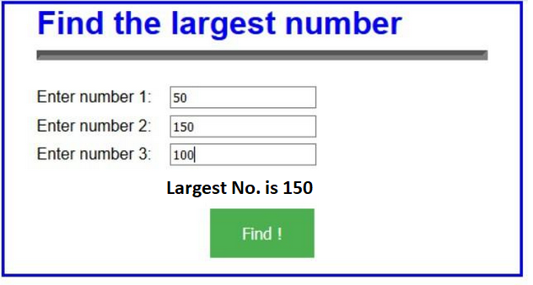

* Create a button using Tailwind CSS
* Get only Numeric value from the user

# Creating Glowing Border Effect green color around Input Fields using CSS

**Q #2** Write a JavaScript conditional statement to find the smallest of three numbers. Display an alert box to show the results.

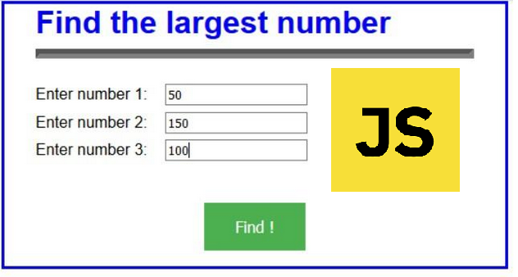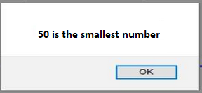

* Show the image on right side of the form
* Placeholder in all input boxes like “Enter only Numeric Value”
* Third value must smaller than second value

**Q #3** Write a JavaScript for loop that iterates from the user. For each iteration, it checks if the current number is odd or even, and displays a message on the screen.

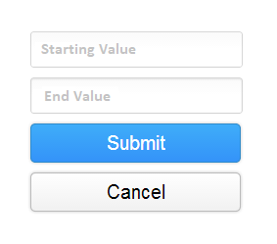

* Create two buttons and apply appropriate Tailwind CSS.
* Check empty fields without required attribute.
* Set placeholder in text boxes.
* Check it the second number must greater than first number

**Q #4** Write a JavaScript Program to Check Prime Number. Display an alert box to show the results.

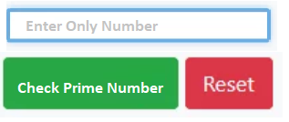

* Create two buttons and apply appropriate Tailwind CSS.
* Check empty fields without required attribute.
* Set placeholder in text boxes.
* Check it only numeric value accept and value must less than 1000.

## **Q #5** Write a JavaScript Program to get a random number from the user in web form and displays a random number of given range on the screen

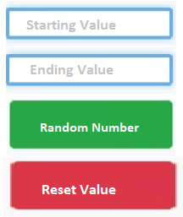

* Create two buttons and apply appropriate Tailwind CSS.
* Check empty fields without required attribute.
* Set placeholder in text boxes.
* Check it only numeric value accept without decimal point.
* Set Text box border color is blue.